In 2017, there were 346 million female gamers in Asia — less than one-third of the total gaming population. By the end of 2019, females accounted for 38% of all gamers across platforms at 500 million strong, and the numbers are continuing to rise.

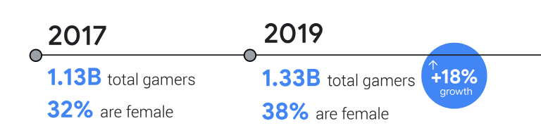

In fact, the number of female gamers in Asia is growing at a faster rate than male gamers.

At the end of 2019, there were 500 million total female gamers in Asia — 8.5 million on consoles, 201 million on PC, and 473 million on mobile, with many choosing to play on multiple platforms

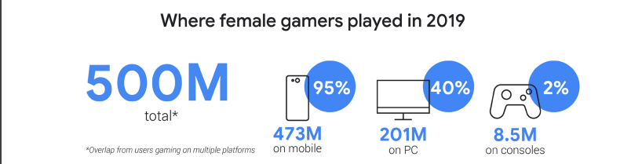

In a survey in 2019 showed that 60% of female gamers spend up to seven hours per week playing, whereas more than half of all male gamers play for more than eight hours a week.

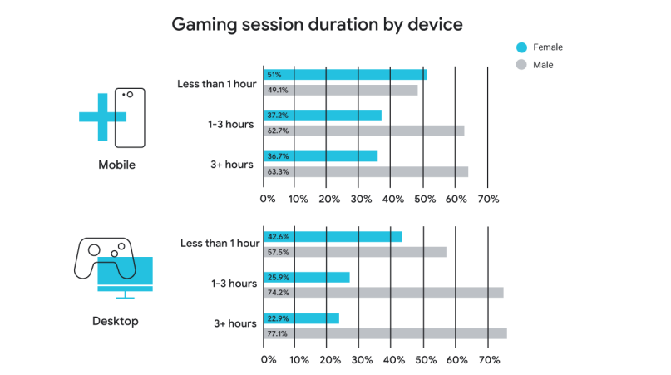

As shown above, we can see that most female gamers are spending more time on mobile. This ultimately translates to higher spends on mobile gaming

Looking at the total gaming spend in each country in 2019, female gamers in China spent $6.6 billion on mobile games and $4.4 billion on PC,15 and in Southeast Asia, they spent $1 billion on mobile games and $660 million on PC.

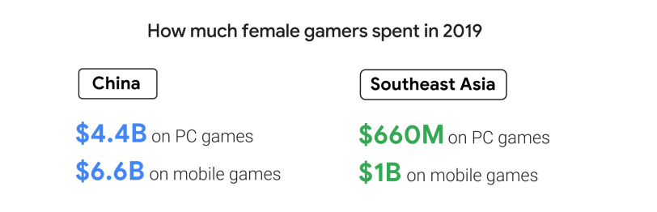

Female gamers tend to prefer multiplayer online battle arena (MOBA), puzzle, and shooter games. Moreover, according to a study by Quantic Foundry, the user base for Match-3 category games (e.g., tile-matching and stacking games like “Candy Crush Saga” and “Jewel Quest”) and Family/Farm sim games is predominantly female.

Role-playing games (RPGs) and simulation titles with strategic gameplay are also hugely popular among female gamers.

In 2018, Chinese developer Xishanju’s CEO Guo Weiwei reported that female gamers made up nearly 50% of Jianxiaqingyuan’s (JX3) user base, despite females typically only accounting for 20% of massively multiplayer online role playing games (MMORPGs) in Asia.

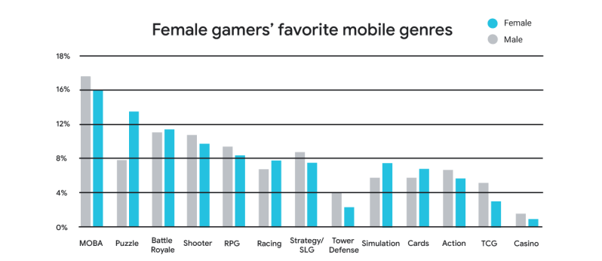

In a survey released by the Game Publishing Commission and Gamma Data Corp, there were 290 million female esports players in China at the end of 2018 - a growth of 11.5% over the same period last year. In China and South Korea alone, women make up one-third of the esports audience, compared to a global average of 22%.25. In Southeast Asia, Independent Women's eSports Tournaments have been growing in popularity since 2012, with players competing in tournaments with titles such as “League of Legends”, “DOTA2” and “DOTA2”. Mobile Legends".

E-sports titles with female participation are likely to attract more female audiences on live video, more female fans, and therefore higher sponsorship value for developers

* From the above analysis, it can be seen that female customers are a new and potential market

Motivation

Some users play the game because they want to learn about the culture of other countries through interacting and making friends with players in other countries in the game. Others play games because they want to have fun and relieve stress after stressful working hours

Perceptiona

In the user's perception of a certain application or game, if their perception of that application or game is bad, it will affect that user's choice not to experience it. If their perception of the app or game is good, they will want to experience it right away

Learning

If a user experiences a game application for the first time and feels that their experience on the game application is good, they will want to stick with it. If their experience is not good, they will choose to stop using it.

Beliefs and Attitudes

If users have negative beliefs about a game application based on learning, it is unlikely that they will continue to use it in the future. Also with a negative attitude about the product, surely one's beliefs and attitudes are quite difficult to change.